
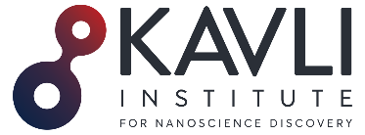
Curriculum Vitae
Carol Vivien Robinson

2. Organization and location

Kavli Institute for Nanoscience Discovery
Dorothy Crowfoot Hodgkin Building
Dorothy Hodgkin Road
Oxford
OX1 3QU, UK
carol.robinson@chem.ox.ac.uk
https://robinsonweb.chem.ox.ac.uk
https://kavlinano.ox.ac.uk
https://www.omass.com

3. PROFESSIONAL PREPARATION
1980 – 1982 Doctor of Philosophy, University of Cambridge. Supervisor: Prof. D. H. Williams FRS
1979 – 1980 Master of Science, University of Wales. Supervisor: Prof. J. H. Beynon FRS
1976 – 1979 Graduate of the Royal Society of Chemistry, Medway College of Technology, Kent
1972 – 1976 ONC and HNC in Chemistry, Canterbury College of Technology, Kent

5. PRODUCTS
CURRENT GRANTS
2023 – 2028 ERC Advanced Grant €2,000,000. IMPLEMENT
2024 – 2028 Bipolar Disorder (BD²) £3,400,000.

Voltage-gated ion channels in Bipolar Disorder (Co-PI)

2021 – 2026 Medical Research Council £1,758,852
Developing MS to understand molecular mechanisms of antibacterial and antiviral drugs
2021 – 2026 Wellcome Trust Investigator Award £2,188,450
Targeting membrane proteins in native environments
2020 - present Kavli Foundation $10 M
Establish The Kavli Institute for Nanoscience Discovery (KIND)
2025 – 2027 Kavli Foundation $ 250,000
Research Ethics and Policy

1. Identifying Information
Carol V. Robinson DBE FRS FMedSci FRSC
Director, Kavli Institute for Nanoscience Discovery/Dr. Lee's Professor of Chemistry, University of Oxford
Orcid ID: 0000-0001-7829-5505
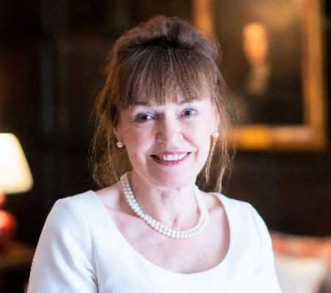

4. APPOINTMENTS AND POSITIONS
2021 Founder Director, Kavli Institute of Nanoscience Discovery
2016 Founder Director, OMass Therapeutics, Oxford
2009 Professorial Fellow, Exeter College, University of Oxford
2009 Dr Lee's Professor of Physical and Theoretical Chemistry, University of Oxford
2006 – 2016 Royal Society Research Professorship

2003 – 2009 Senior Research Fellow, Churchill College,
University of Cambridge
2001 – 2009 Professor of Mass Spectrometry, Department of
Chemistry, University of Cambridge
1999 – 2001 Titular Professor, University of Oxford
1998 – 2001 Research Fellow, Wolfson College, University of Oxford
1995 – 2001 Royal Society University Research Fellow, Oxford
1991 – 1995 Postdoctoral Research Fellow, University of Oxford
Supervisor: Prof. C. M. Dobson FRS
1991 – 1991 Postgraduate Diploma in Information Technology,
University of Keele
1983 – 1991 Career break to raise a family
1982 – 1983 MRC Training Fellowship, University of Bristol
1972 – 1979 Laboratory Technician, Pfizer, Sandwich, Kent

Technologies and techniques
During her early research, Carol developed and applied mass spectrometry to show how protein folding could be monitored in the presence of molecular chaperones. This research prompted her to find new ways to preserve mega Dalton complexes in the gas phase and led her to uncover the heterogeneity and dynamics of numerous multi-protein complexes.

In recent work, she has demonstrated the numerous roles played by lipids in regulating the structure and function of membrane protein assemblies.

Her current interest is in uncovering the synergy of lipid and drug binding. Informed by this research, she is exploring new ways to characterise receptor-signalling complexes.

Inventions, patent applications and licenses
Carol is a co-inventor on ten patents that are primarily focussed on the mass spectrometry of membrane proteins with various enabling features such as bespoke detergents, novel ionization methods, and new instrumentation. Six patents have been licensed.

Selected examples:

Detection of membrane protein-therapeutic agent complexes by mass spectrometry
Patent number: 9536718
Inventors: Carol V. Robinson, Sheila Wang, Nelson P. Barrera.
Filed: 2012
Granted: 2017.

Dendritic detergents for the analysis of proteins by mass spectrometry
Publication number: 20210188902
Inventors: Carol V. Robinson, Idlir Liko, Hsin-Yung Yen, Kevin Pagel, Rainer Haag, Svenja Christina Ehrmann, Leonhard Hagen Urner.
Filed: 2021.

Detection of membrane proteins by mass spectrometry
Publication number: 20210325402
Inventors: Dror S. Chorev, Carol V. Robinson.
Filed: October 21, 2021

New business creation
As scientific co-founder of OMass Therapeutics, Carol helped raise Series B investment (US$110 million) from a syndicate of well-established investors, including Google Ventures, Syncona, Sanofi, and Northpond.

Using mass spectrometry, OMass are identifying and progressing new medicines to treat patients with rare
conditions and diseases that don't respond to treatments already on the market.

The company, whose defining technology is mass spectrometry, has now established more than 50 jobs and initiated on a brown-field site on the outskirts of Oxford.
On founding OMass and recent
Discovery of a new potential therapy for IBD

6. SYNERGISTIC ACTIVITIES

Outreach, women in STEM and diversity
Carol has had an unorthodox career path, which began to take shape when she completed her graduate education while working full-time in industry. She then completed her PhD from the University of Cambridge in two years. Following an eight-year career break to raise her three children, she returned to research at Oxford.

In 2001, she became the first female Professor of Chemistry at the University of Cambridge, returning to Oxford in 2009 upon election to the Dr. Lee's Chair of Physical and Theoretical Chemistry.

Based on her extensive and varied experience throughout this journey, she regularly presents at Women in Science events and mentors many scientists. Her research group is consistently diverse, and ~30 of her researchers have gone on to establish independent academic groups worldwide.

Carol is also a member of the Advisory Board of the Royal National Children's Springboard with a mission to widen access to the best schools for young people facing the greatest barriers to development.

Advocacy and Leadership
As president of the Royal Society of Chemistry, Carol focussed on the roles of technicians and support staff in teaching and research laboratories. As President Elect of the Society, and as a former technician herself, Carol was keen to begin launching the Technician's Charter. This charter was designed to increase Visibility, Recognition and Career Development of technical staff. She continued to promote this cause throughout her presidency, presenting the first awards to technical staff and delivering lectures to highlight the roles of technicians. Over 100 higher education institutions have now signed up to this scheme, with the charter displayed in entrance halls across the UK.

In 2020, Carol became the founding director of the Kavli Institute for Nanoscience Discovery in Oxford (KIND), an interdisciplinary science institute with a mission to bring together eight different departments across two divisions. To coincide with this opening, Carol applied for funding to initiate a Research Culture Program to give all researchers a voice in shaping the institute and to introduce a collaborative, supportive and non-competitive environment.
On founding the Kavli Institute

Today the institute is over-subscribed with many scientists from the eight departments competing for space. Moreover, the institutes ‘open-door’ policy means that it regularly hosts scientists from disadvantaged backgrounds and ethnic minorities, and it has recently secured significant research funding as well as grants for displaced scientists.

She recently secured further funding from the Kavli Foundation to appoint Research Fellows in Ethics and Policy to engage with researchers to identify and ameliorate ethical risks and to promote responsible research practice.

